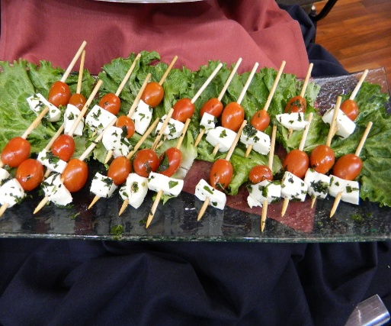

Menu

Appetizers:

Bruschetta

Cucumbers and Salmon Slices

Charcuterie Grazing Board

Hummus w/ choice of fresh veggies or Naan Bread

Summer Caprese w/ Naan Bread

Caprese Skewers

Deviled Eggs

Spinach Artichoke Dip w/ Chips

Buffalo Chicken Dip w/ Pita Chips

Grilled Shrimp w/ Cocktail Sauce

Fresh Fruit Tray or Skewers

Veggie Tray

Wingz (Fried or Baked)

Meatballs

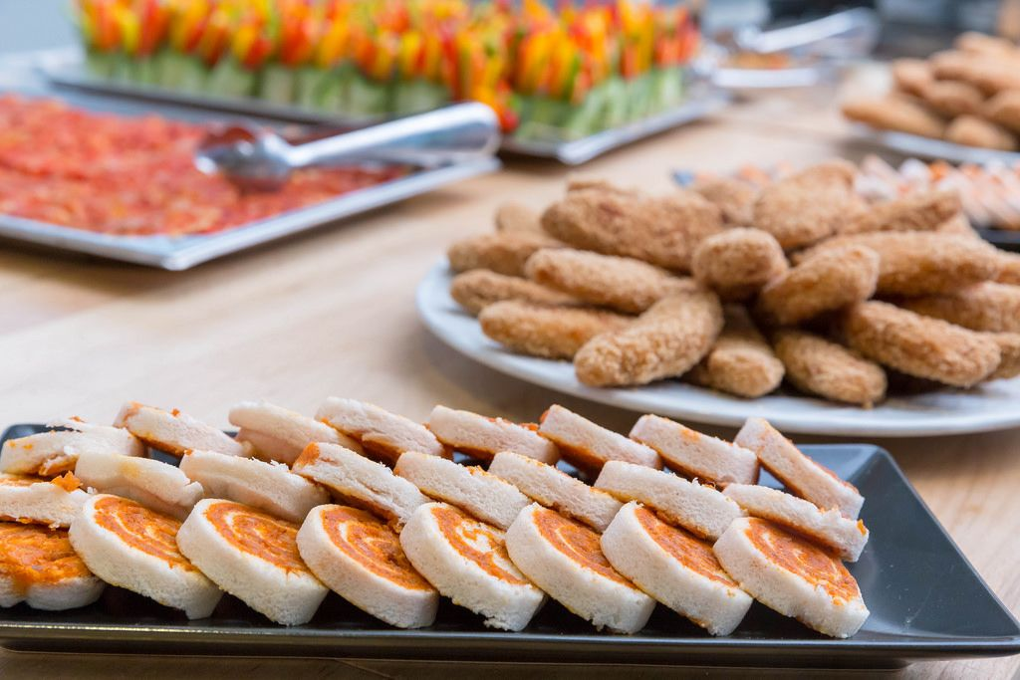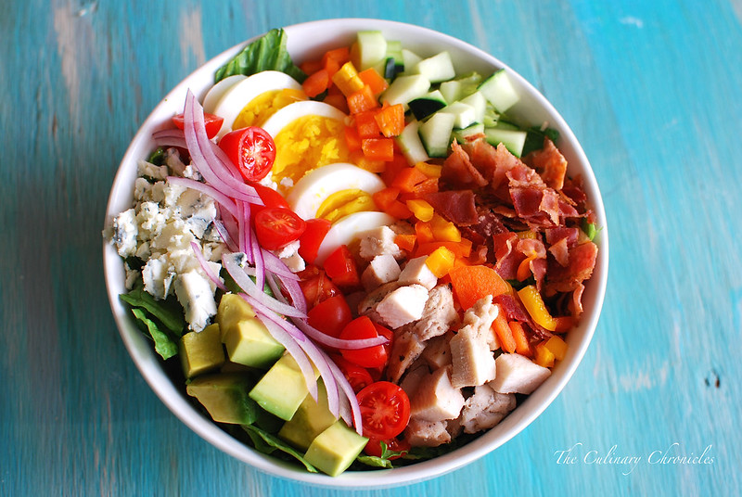

Salads

**Caprese** (Cherry Tomatoes, Fresh Moz., Fresh Basil, Balsamic Vinaigrette Served w/ Naan Triangles

**Caesar** (Spring Mix, Croutons, Shaved Parmesan, Caesar Dressing)

Wedge (Quarter of head iceberg, bacon crumbles, red onions, cherry tomatoes, creamy blue cheese dressing., pecans.)

Cobb (Bed of Spring Mix, row of cooked chicken, cherry tomatoes, avocado, hard boiled eggs, blue cheese w/ red wine vinaigrette)

House (Spring Mix, Cucumbers, Cherry Tomatoes, Bacon Crumbles, Cheddar Cheese, Red onions,

Pasta (Pasta Salad or Potato Salad)

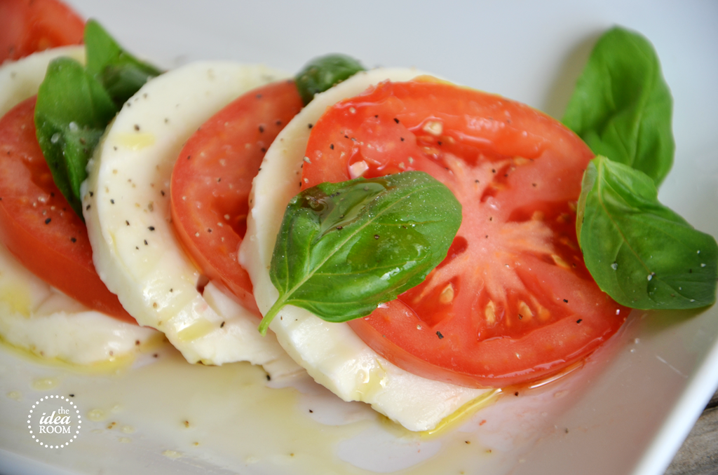

Sides

Fresh Green Beans w/Smoked Meat

Fresh Asparagus

Fresh Broccolini

Baked Mac and cheese

Baked Potatoes (loaded optional)

Mashed Potatoes

Roasted Root vegetables

Grilled Kabobs

Baked Beans

Roasted Brussel Sprouts

Roasted Potatoes

Butter Basil Corn

Cheesy Au Gratin Potatoes

Sweet Potatoes (Diced or Yams)

Main Dishes

Blacked Salmon (8oz salmon blackened with season and seared)

Honey Glazed Seared Salmon

Roasted Chicken w/ Herb Infusion

Chicken Marsala w/ Mashed Potatoes & Asparagus

Chicken Parmesan w/ Noodles

Lemon Pepper Glazed Grilled Chicken Breast

Double Crunch Fried Chicken

6 or 8 oz. Filet Mignon

Pastas

Alfredo (A Homemade cream sauce with your choice of protein Shrimp, Chicken, or Steak Tips)

Shrimp Scampi

Marry Me Pasta (Seasoned Tomato Creamed Sauce w/ two choices of proteins: Chicken, Shrimp, Kaboos Rope, Topped with Diced Tomatoes and Cilantro or mint)

Spaghetti w/ Meatballs (Homemade Sauce topped w/ Meatballs and parsley)

Vodka- Tomato Cream Sauce (Bowtie or Rotini Noodles)

Vodks Sauce Tortellini

Tortellini & Spinach Pasta

Bolognese Pasta

Homemade Lasagna

Bars

Taco Bar (Taco Meat, Cheese Blend, Diced Tomatoes, Shredded Lettuce, Shells (Soft & Hard Corn) Guacamole, Sour Cream) Include Chip and Queso & Salsa)

Salad Bar (Spring Mix-Romaine Blend, Diced Tomatoes, Cheese Blend, Cucumbers, Bacon Bits, Red Onions, Croutons, Hard Boiled Eggs) ( Italian, French, Ranch, Caesar, Citrus Raspberry and Balsamic Vinaigrette,

American Bar (Burgers, Hotdogs, Potato Chips, Winz, Potato Salad, Pasta Salad.)

All Entrées Come W/ Two Sides, Homemade Garlic Bread & Side Salad



